C&C TRAINING OPENS SECOND TRAINING OFFICE IN SUFFOLK
-Training Services Provider Marks Four Years of Year-on-Year Growth with Further Business Expansion-
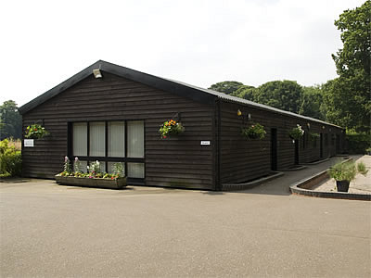
Date: Training services provider, C&C Training, is today opening its second training centre, located in Suffolk, off the back of four consecutive years’ business growth.
Since its foundation in 2007, C&C Training, a specialist in sourcing, developing and delivering training courses and services to the business community, has seen revenues grow annually by an average of 180% and has seen its client base expand to include over 255 companies whilst maintaining a 100% client retention rate.
Ruth Crothers, C&C Training’s Operations Director, explains, “Our business philosophy is one which may sound simple – to focus absolutely on delivering quality services that are centred on our clients’ needs – but which is actually very difficult to maintain. It is because of our unique combination of skills and experience within different aspects of the training industry, and by consistently standing by these principles, that we have been able to thrive in a very challenging economic period.”
C&C Training was set up by Ruth Crothers and Charlie Cadman, who combined have nearly 30 years’ experience within the training services industry; Charlie from the delivery perspective and Ruth as an HR and personnel manager responsible for selecting and developing training within organisations.
This background has enabled C&C Training to develop a holistic approach to its training courses, which has seen the company grow in partnership with its clients. Today, C&C Training boasts accreditations with the training industry’s major regulatory bodies, including IOSH, NEBOSH, RTITB and Construction Skills, City & Guilds and UKATA. The company offers opportunities for tailored and bespoke training alongside a course list of over 100 recognised courses in areas that include operational and technical skills as well as leadership & management, personnel development and HR.
-more news overleaf-
-news release continued-
Charlie Cadman, C&C Training’s Commercial Director, adds, “We take great pride in delivering training that provides real business value and go to great lengths to ensure the quality of our service provision – from the trainers we use, who are all accredited and experienced in their individual fields, to our premises. We are very excited to have the opportunity to open our second training centre in two years.”
She concludes, “As a business and a service provider, we know what we are doing right and will continue to do so moving forward.”
ENDS
About C&C Training
C&C Training is an accredited provider of training services to the business community with over 35 combined years of experience in sourcing, developing and delivering training.

Founded in 2007, C&C Training was set up by directors Ruth Crothers and Charlie Cadman, on the philosophy that good quality training does not have to cost the earth and that the customer is King. C&C Training adopts a holistic approach to the training it offers its clients; by working in partnership with its customers, C&C Training delivers both Technical and Operational training courses and develops tailored People training courses designed to meet its clients’ specific business needs.

With over 100 existing courses recognised by industry bodies including City & Guilds, IOSH, NEBOSH, Construction Skills, RTITB and UKATA, an ever expanding course range and opportunities for tailored and bespoke programmes across a range of industry and business sectors including health & safety, HR, IT skills, plant & construction and driver training as well as leadership & management and personal development, C&C Training can offer its clients accessible, affordable and high quality training, both from its own dedicated development and training centres in Leighton Buzzard and Bury St Edmunds, and at its clients’ own premises.
C&C Training has five full-time employees and 48 trainers, all of whom are accredited, CPD-checked and experienced specialists in their individual fields. This team is passionate and committed to supporting C&C’s clients to source, develop and deliver training of the highest quality; an ethos that is endorsed by the fact that C&C Training has a 100% client retention rate.

For more information, please contact:
C&C Training Ltd or PR Manager
Head Office: 01525 851 752 Josephine Carr
Suffolk Office: 01449 672 500 Tel: 07775 902 119
enquiries@cctraining.uk.com josephine.carr@hotmail.co.uk
www.cctraining.uk.com

